Shree Swaminarayan College of Computer Science

(Affiliated to M. K. Bhavnagar University)

Shamballa

BY

Soneji Sagar Vijaykumar

UNDER GUIDANCE OF
Mr. Parthik Patel

SUBMITTED TO

SHREE SWAMINARAYN COLLEGE OF COMPUTER SCIENCE

FOR DEGREE OF

BACHALOR OF COMPUTER APPLICATIONS


Shree Swaminarayan College of Computer Science

(Affiliated to M. K. Bhavnagar University) GURUKUL CAMPUS, SARDARNAVAR, BHAVNAGAR-364001

SHREE SWAMINARAYAN
COLLEGE OF COMPUTER SCIENCE
Gurukul Campus, Sardarnagar, Bhavnagar. 364001. (Guj)

Phone : 0278-2568222
Fax : 0278-2568222
e-mail : director@swamigurukul.com Visit us at : www.swamigurukul.com
( Affiliated to Maharaja Krishnakumarsinhji Bhavnagar University)

COLLEGE CERTIFICATE

This is to certify that Mr. Soneji Sagar Vijaykumar

Seat No 25260239 student of Bachelor of Computer Application (BCA)

Semester-VI, in our institute has successfully completed the project assigned to his/her at entitled Shamballa during the period December-2023 to April-2024 as a part of Bachelor of Computer Application (BCA) syllabus (2023-2024).

Date :
Place : Bhavnagar Project Guide I/C Principal

PREFACE

- In the Bachelor of Computer Applications (BCA) Semester 6 curriculum, there is a subject specifically dedicated to project work. The primary objective of this project is to facilitate the acquisition of both practical and theoretical knowledge applicable to various business forms and organizations.

- Engaging in this project aids students in advancing toward the practical implementation of systems. It serves as a test of patience and work capability while fostering invaluable experiential learning.

- Throughout the duration of this project, our endeavor was to uphold professionalism and recognize our capacity to tackle challenges effectively.

- We studied documents pertaining to the Shamballa as a reference for our project. It is my pleasure to present this project work as part of our subject. Through
this project, we have gained invaluable insights and experiences.

- This project report delves into the Shamballa, Explore Shamballa: donate to support our facilities and temple, shop for cultural treasures, and discover our sacred space for a brighter tomorrow.

ACKNOWLEDGEMENT

- Upon the successful culmination of my work, I extend my heartfelt appreciation to all those who supported me during my project at Shree Swaminarayan College of Computer Science, Bhavnagar.

- I would like to express my gratitude to our principal, Mr. Paresh Rathod and DR. KALPESH U.GUNDIGARA [ACADEMIC HEAD, SSCCS], for providing me with the opportunity to work within this esteemed institution. I am truly thankful to Mr. Parthik Patel, my guide, for his invaluable guidance throughout the project. His decision to entrust me with a real project and his confidence in my abilities are deeply appreciated. Additionally, I extend my thanks to the entire SSCCS community for their assistance.

- I also want to acknowledge my guide, Mr. Parthik Patel, for his constant encouragement and insistence on meeting deadlines, which motivated me to strive for excellence.

- Lastly, I am grateful to all those who contributed to my project, even if their names are not mentioned here.

TABLE OF CONTENT

Sr. No. | Title |  | Page No.
1. | Project Profile |  | 4
2 | Introduction |  | 6
 | 2.1 | objective
 | 2.2 | Background
 | 2.3 | Purpose & Scope
3 | Requirement Analysis |  | 9
 | 3.1 | Problem Definition
 | 3.2 | Requirement Specification
 | 3.3 | Planning & Scheduling
4 | System Analysis |  | 12
 | 4.1 | Functional Requirement
 | 4.2 | Feasibility Study
5 | System Design |  | 17
 | 5.1 | DFD
 | 5.2 | ER-Diagram
 | 5.3 | DATA Dictionary
 | 5.4 | Organizational chart
6 | Screen Design |  | 33
7 | Testing and Implementation |  | 49
 | 7.1 | Introduction of Testing
 | 7.2 | Test Case
 | 7.3 | Implementation
8 | Future Enhancement |  | 63
9 | Conclusion |  | 66
10 | Bibliography |  | 69
 | 10.1 | Books Reference
 | 10.2 | Website Reference

1.Project Profile

Project Profile

Project title | Shamballa
Project Definition /Goal | Empower temple devotees to easily make donations online through our  user-friendly website.
Project Guide | Mr. Parthik Patel
Team Size | 1
Operating System | Microsoft Windows 11
Front end used | Html,css,javascript,PHP
Back end used | Php,MysSql Database
Project Duration | 3 month
Submitted by | Soneji Sagar V.
Submitted To | Shree Swaminarayan College of Computer Science.  Gurukul campus, Sardarnagar, Bhavnagar-  364001.

2.Introduction

Introduction

- Welcome to Shamballa Dive into our website to discover our peaceful sanctuary. Learn about our mission, explore our facilities, and join our community dedicated to harmony and enlightenment. Welcome to a place where peace prevails and purpose thrives.

Objective:

    - The main goal of Shamballa is to gather donations for our temple's needs. Your contributions help us maintain our facilities, support temple activities, and ensure our community thrives.

    - With your generosity, we can continue spreading spirituality and cultural heritage to all who seek it. Thank you for being a part of our journey towards a better tomorrow.

Background:

    - Shamballa is temple donation system website.

    - The website is useful for devotees can choose temple to donate.

    - Our project is developed on PHP and MySQL.

    - Our website has a mini shop where devotees can purchase products related to the temple.

    - Other facility is to temples information and

temple event information.

Purpose & Scope

    - The Shamballa Temple website aims to create a comprehensive online platform that caters to the diverse needs of our devotees and visitors.

    - The project scope encompasses providing essential informationsuch as darshan and aarti timings, offering a glimpse into the rich history of Shamballa, and showcasing the temple's beauty through a vibrant gallery.

    - Additionally, the website facilitates seamless donations to support the temple's activities and initiatives.

    - It features an online shop where visitors can explore and purchase religious artifacts, literature, and spiritual items.

    - The inclusion of an events section ensures that users stay informed about upcoming temple-related activities, fostering a sense of community engagement.

    - Overall, the Shamballa Temple website seeks to enhance the spiritual experience and connection between the temple and its followers by combining informative content with interactive features.

3.Requirement Analysis

Problem definition

    - Currently, managing donations at the temple involves manual processes, making it challenging to keep track of contributions effectively.

    - Donations are often recorded by hand, leading to errors and difficulty in maintaining privacy. To address these issues, we aim to develop a system that simplifies the donation process.

    - This system will allow donors to contribute easily and securely, while providing the temple with a reliable way to track donations and maintain donor privacy.

Requirement Specification

    - Software Requirement:-

Operating System | Windows 7 or higher
Fronted | HTML , css, Gsap , Javascript , Boostrap5.
Backend | MySQL
Tools | Visual Studio Code
Server | XAMPP

Hardware Requirement:-

Processor | Core i3 32bit,1.80GHz
RAM | 2 GB or higher

  - Planning and scheduling

Planning | 5 days
Analysis | 10 days
Designing | 25 days
Coding | 35 days
Testing | 5 days
Documentation | 15 days

4.System Analysis

System Analysis of Shamballa

- The Shamballa temple website is thoughtfully structured into distinct modules, each serving a vital purpose in facilitating seamless navigation and user experience. Recognizing the importance of logical separation for efficient development and testing, our website modules are designed to uphold simplicity without compromising effectiveness. The systematic organization of our website ensures clarity and accessibility for visitors seeking spiritual guidance and connection. The different modules include:

Functional Requirement

    - Temple Information :
      - Delve into the rich history, significance, and offerings of the Shamballa temple.
      - Explore details on Darshan Time, Aarti Time,Histoy and captivating Photos capturing the essence of our sacred space.

Donation :

      - Support our noble endeavors by contributing through our Donation module.

      - Your generous donations help sustain our temple, support community initiatives, and uphold our spiritual mission.

      - Every contribution makes a difference in nurturing our sacred space.

Shop:

      - Explore divine treasures and spiritual essentials in our Shop module. Browse through a curated selection of merchandise inspired by Hindu culture, including sacred artifacts, religious literature, and handcrafted offerings.

      - Each item reflects the spiritual essence of Shamballa.

Events :

      - Stay connected with the vibrant tapestry of events and celebrations at Shamballa through our Events module.it shows recent events photos and events information.

      - Like event location, event date and event description.

User Login and signup:

      - User Login require for temple donation and shop only.

        - UserName
        - Password

Accessibility and Performance:

      - Optimize website performance for fast loading times and responsiveness across devices.

      - Ensure color contrast ratios meet accessibility standards for readability.

      - Implement keyboard navigation and focus management for users who cannot use a mouse.

Feasibility Study

- Before proceeding with the development of the Shamballa Temple website, we conducted a thorough feasibility study to assess its viability. This study focused on three key aspects:

Technical Feasibility:

  - Developing a website requires specific software and hardware resources.

  - Fortunately, Shamballa Temple possesses the necessary infrastructure or can easily acquire them. This technical readiness ensures that the project is technically feasible, laying a strong foundation for its

development.

Economical Feasibility:

  - The proposed website for Shamballa Temple is economically feasible. There are no significant investments or purchases required.
  - The website primarily relies on basic resources such as hosting services and web development tools. This cost-effective approach minimizes financial burden while achieving our website's objectives.

Operational Feasibility:

  - Currently, Shamballa Temple operates with manual processes. This includes managing temple activities, events, and donations.

  - The proposed website aims to streamline these operations by automating complex tasks such as shop, donation, event scheduling, and information dissemination. By implementing this system, we enhance operational efficiency and provide a user- friendly experience for both temple administrators and visitors.

5.System Design

System Design

  - DFD(Data Flow Diagram)

    - A data flow diagram shows how data is processed within a system based on inputs and outputs. Visual symbols are used to represent the flow of information, data sources and destinations, and where data is stored.

    - Data flow diagrams are often used as a first step toward redesigning a system.

    - They provide a graphical representation of a system at any level of detail, creating an easy-to- understand picture of what the system does. A general overview of a system is represented with a context diagram, also known as a level 0 DFD, which shows a system as a single process.

    - A level 1 diagram provides greater detail, focusing on a system’s main functions. Diagrams that are level 2 or higher illustrate a system’s functioning with increasing detail.

    - It’s rare for a DFD to go beyond level 2 because of the increasing complexity, which makes it less effective as a communication tool.

RULES FOR DFD:
  - Fix the scope of the system by means of context diagrams.

  - Organize the DFD so that the main sequence of the actions.

  - Reads left to right and top to bottom.

  - Identify all inputs and outputs.

  - Identify and label each process internal to the system with Rounded circles.

  - A process is required for all the data transformation and Transfers. Therefore, never connect a data store to a data Source or the destinations or another data store with just a Data flow arrow.

  - Do not indicate hardware and ignore control information.

  - Make sure the names of the processes accurately convey everything the process is done.

  - There must not be unnamed process.

  - Indicate external sources and destinations of the data, with Squares.

  - Number each occurrence of repeated external entities.

  - Identify all data flows for each process step, except simple Record retrievals.

  - Label data flow on each arrow.

  - Use details flow on each arrow.

  - Use the details flow arrow to indicate data movements.

Data Flow Diagram Notaions

  - DFDs are designed in a way so that it will become easier to understand DFD as well as its base system.

  - Even drawing DFD is also an easy task to perform because all drawn DFDs use unified notations to represent the system.

  - These notations are divided into 2 categories.

- Yourdon
- Gane – Sarson.

- Four basic notations are used to draw DFD…

External Entity

Yourdon and Coad Gane and sarson

  - Also known as actors, sources or sinks, and terminators, external entities produce and consume data that flows between the entity and the system being diagrammed. These data flows are the inputs and outputs of the DFD. Since they are external to the system being analyzed, these entities are typically placed at the boundaries of the diagram. They can represent another system or indicate a subsystem.

Process

Yourdon and Coad Gane and sarson

  - An activity that changes or transforms data flows. Since they transform incoming data to outgoing data, all processes must have inputs and outputs on a DFD. This symbol is given a simple name based on its function, such as “Ship Order,” rather than being labeled “process” on a diagram. In Gane- Sarson notation, a rectangular box is used and may be labeled with a reference number, location of where in the system the process occurs and a short title that describes its function. Processes are typically oriented from top to bottom and left to right on a data flow diagram.

Data Store:

Yourdon and Coad Gane and Sarson

  - A datastore does not generate any operations but simply holds data for later access. Datastores could consist of files held long-term or a batch of documents stored briefly while they wait to be processed. Input flows to a data store include information or operations that change the stored data. Output flows would be data retrieved from the store.

Data Flow:

Yourdon and Coad Gane and Sarson

  - The movement of data between external entities, processes, and data stores is represented with an arrow symbol, which indicates the direction of flow. This data could be electronic, written, or verbal. Input and output data flows are labeled based on the type of data or its associated processor data store, and this name is written alongside the arrow.

Context Level DFD / 0 Level DFD:

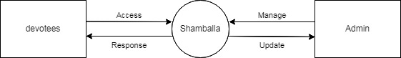

- 1st Level User DFD
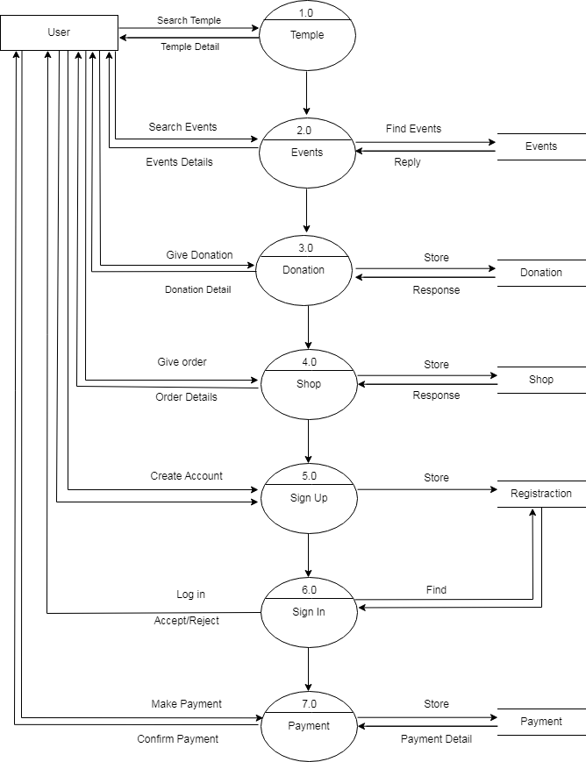

1st Level Admin DFD

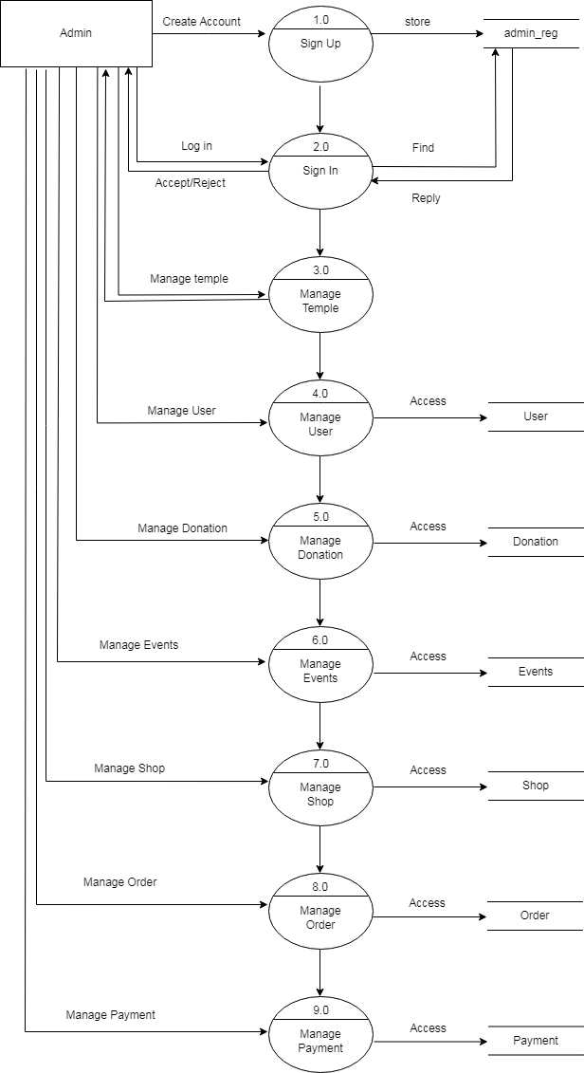

  - E-R diagram

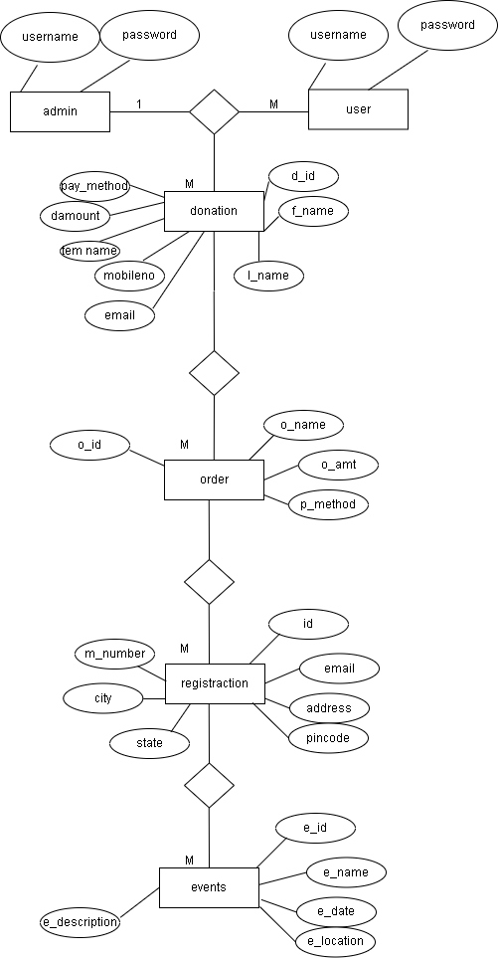

  - Data Dictionary:-

Table Name :- donation
Database Name :-Shamballa |  |  |  | Primary Key :  D_ID
Foreign Key :- |  |  |  | Reference :-
Sr.  No. | Field Name |  | Data Types | Field Size (bytes) | Format | Nul l | Description
1 | D_id |  | Int | 11 |  | No | Unique identifier for each donation record.
2 | F_name |  | Varchar | 20 | User Input | NO
3 | L_name |  | Varchar | 20 | usernput | NO
4 | email |  | varchar | 40 | usernput | NO
5 | Mobile no |  | Int | 10 | usernput | NO
6 | Tem_name |  | Varchar | 40 | usernput | NO
7 | D_amount |  | Decimal | (10,0) | usernput | NO
8 | Pay_method |  | Varchar | 30 | Usernput | NO
9 | Cardnumber |  | Varchar | 16 | Usernput | NO
10 | Expirydate |  | Varchar | 7 | Usernput | NO
11 | cvv |  | Varchar | 3 | Usernput | NO
Total No Of Fields  11 |  | One Row Size (in bytes)  207 |  |  | No of Records expected |  |  | Overall Size Of Table
: Table Remark:
This table describes the donation

Table Name :- Events
Database Name :- Shamballa |  |  |  | : Primary Key :  E_ID
Foreign Key :- |  |  |  | Reference :-
Sr.  No. | Field Name |  | Data Type s | Field Size  (byte s) |  | Form at | Null |  | Description
1 | E_ID |  | Int | 10 |  |  | No |  | Auto increment
2 | E_ name |  | Varch ar | 30 |  |  | NO |  | User input name
3 | E_date |  | Date |  |  |  | NO
4 | E_img |  |  |  |  |  | NO
5 | E_location |  | Varch ar | 50 |  |  | NO
6 | E_desc |  | text |  |  |  | NO
Total No Of Fields  6 |  | One Row Size (in bytes)  90 |  |  | No of Records expected |  |  | Overall Size Of Table
: Table Remark:
This table describes the events

Table Name :- Product
Database Name :- Shamballa |  |  |  | : Primary Key :  P_ID
Foreign Key :- |  |  |  | Reference :-
Sr.  No. | Field Name |  | Data Types | Field Size (bytes) |  | Format | Null | Description
1 | P_ID |  | Int | 11 |  |  | No | Auto increment
2 | P_name |  | Varchar | 255 |  |  | NO
3 | P_img |  |  |  |  |  | NO
4 | P_des |  | Text |  |  |  | NO
5 | p_price |  | Decimal | (10,2) |  |  | NO
Total No Of Fields  5 |  | One Row Size (in bytes)  276 |  |  | No of Records expected |  |  |  | Overall  Size Of Table
: Table Remark:
This table describes the product

Table Name :- registraction
Database Name :- Shamballa |  |  |  | : Primary Key :  user_ID
Foreign Key :- |  |  |  | Reference :-
Sr.  No. | Field Name |  | Data Types | Field Size (bytes) |  | Format | Nul l | Descriptio n
1 | User_ID |  | Int | 10 |  |  | No | Auto increment
2 | fullname |  | Varchar | 50 |  | User Input | NO
3 | city |  | Varchar | 20 |  | User Input | NO
4 | email |  | Varchar | 50 |  | User Input | NO
5 | Phone no |  | Varchar | 10 |  | User Input | NO
6 | Address |  | Varchar | 100 |  | User Input | NO
7 | Pincode |  | Varchar | 7 |  | userinput | NO
8 | state |  | Varchar | 20 |  | userinut | NO
Total No Of Fields  8 |  | One Row Size (in bytes)  217 |  |  | No of Records expected |  |  | Overall Size Of Table
Table Remark:
This table describes the registration

Table Name :- signup
Database Name :- Shamballa |  |  |  | : Primary Key :  user_ID
Foreign Key :- |  |  |  | Reference :-
Sr.  No. | Field Name |  | Data Types | Field  Size (bytes) |  | Format | Nul l | Description
1 | user_ID |  | Int | 11 |  |  | No
2 | Username |  | Varchar | 20 |  | User Input | NO
3 | Password |  | Varchar | 10 |  | userinput | NO
Total No Of Fields  3 |  | One Row Size (in bytes)  41 |  |  | No of Records expected |  |  |  | Overall Size Of  Table
: Table Remark:
This table describes the signup

Table Name :- order
Database Name :- Shamballa |  |  |  | : Primary Key :  order_ID
Foreign Key :- |  |  |  | Reference :-
Sr.  No. | Field Name |  | Data Types | Field Size (bytes) |  | Format | Null | Descripti on
1 | order_ID |  | Int | 30 |  |  | No
2 | o_name |  | Varchar | 60 |  |  | NO
3 | 0_amt |  | Int | 5 |  |  | NO
4 | P_method |  | Varchar | 15 |  |  | NO
5 | c_name |  | Varchar | 40 |  |  | NO
6 | c_no |  | Varchar | 15 |  |  | NO
7 | Exp_m |  | Varchar | 15 |  |  | NO
8 | Exp_y |  | Int | 5 |  |  | NO
9 | c_cvv |  | Int | 4 |  |  | NO
Total No Of Fields  8 |  | One Row Size (in bytes)  189 |  |  | No of Records expected |  |  | Overall Size Of Table
: Table Remark:
This table describes the order

  - Orgazizational chart

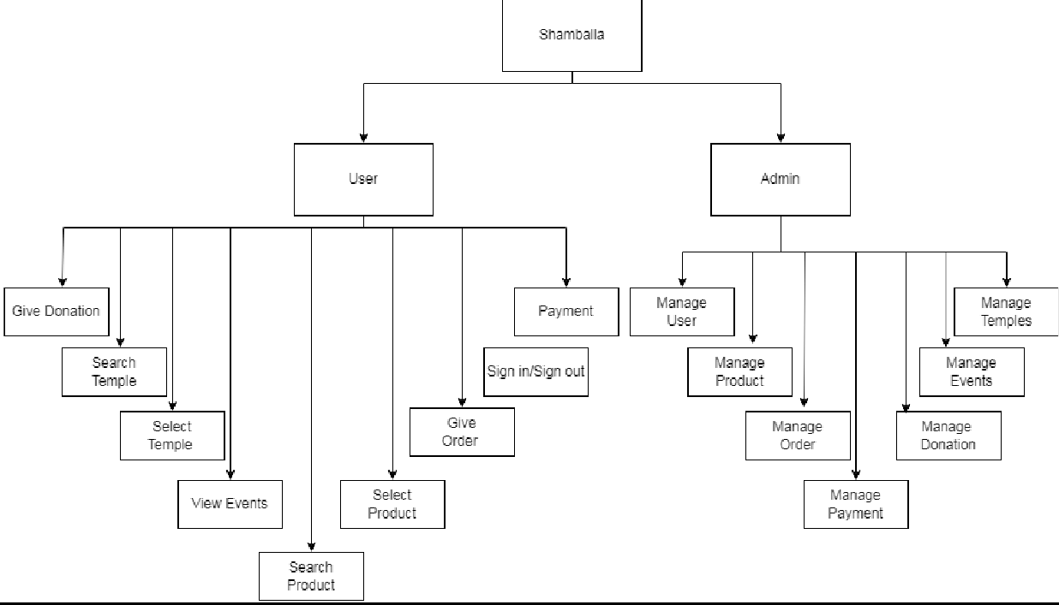

6.Screen Design

Screenshot

- Home page:-

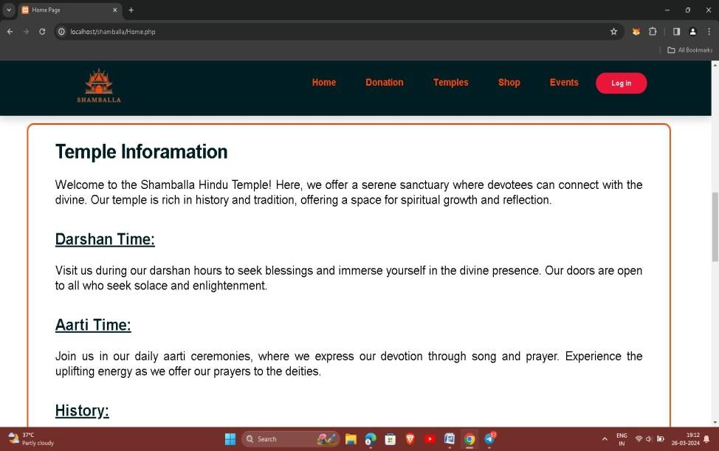

  - This is home page to display the website pages information.

Donation Page:-

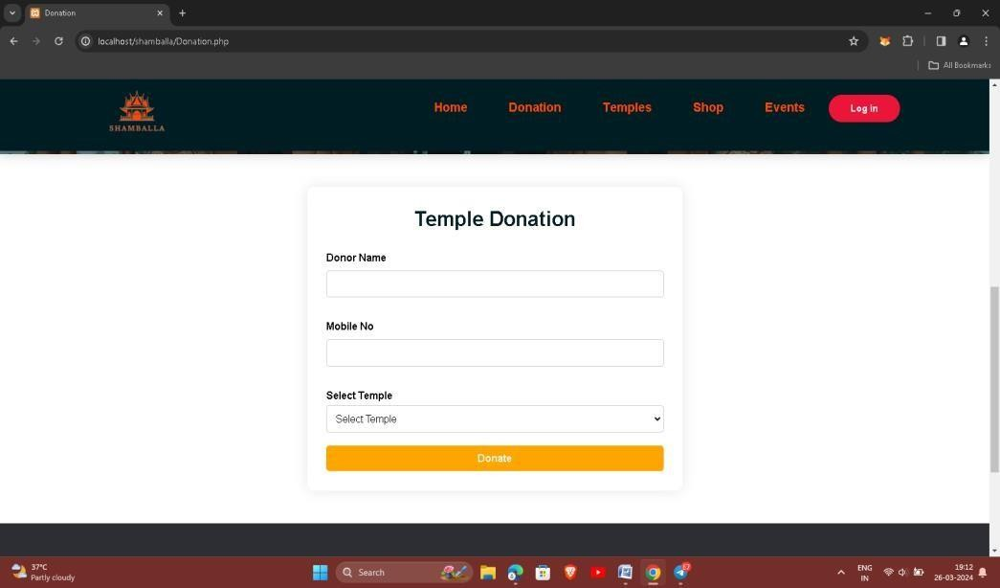

  - This is donation page to devotees can donation in temple.

  - Here, Enter a donor name ,mobile no and choose temple which can donate.

Temples page:-

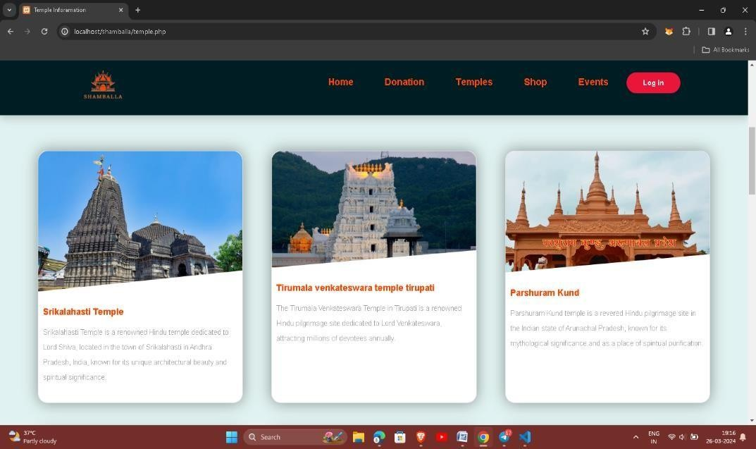

- Here, temples information cards.
- Click any cards to get information of temple.

Temple Sub page:-

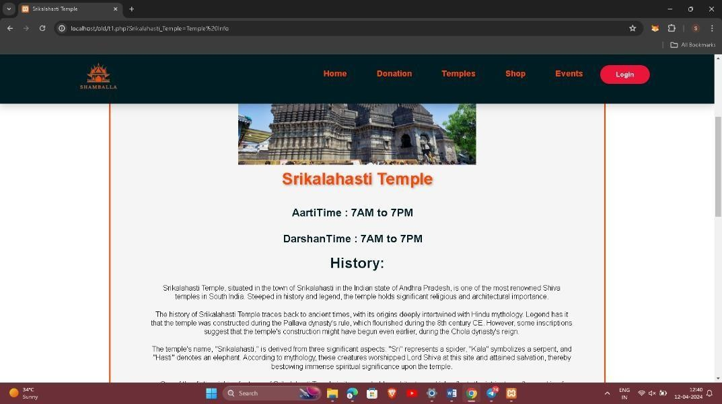

  - This is temples sub page.
  - It is display the specific information like temple darshan time,aarti time,history and gallery.

Shop page:-

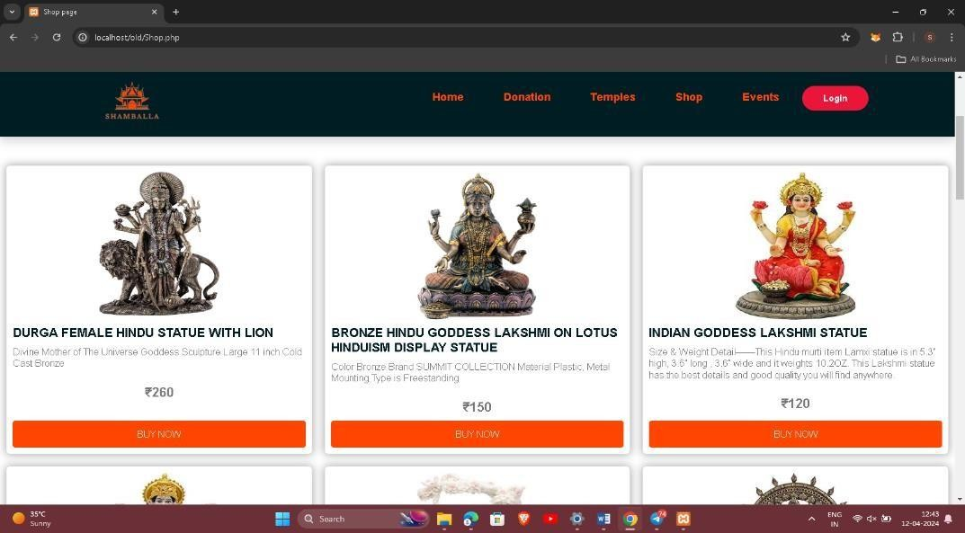

  - This is a shop page of our website.
  - It is show the temple related product like statue, books etc.
  - User can purchase any product.

Login page:-
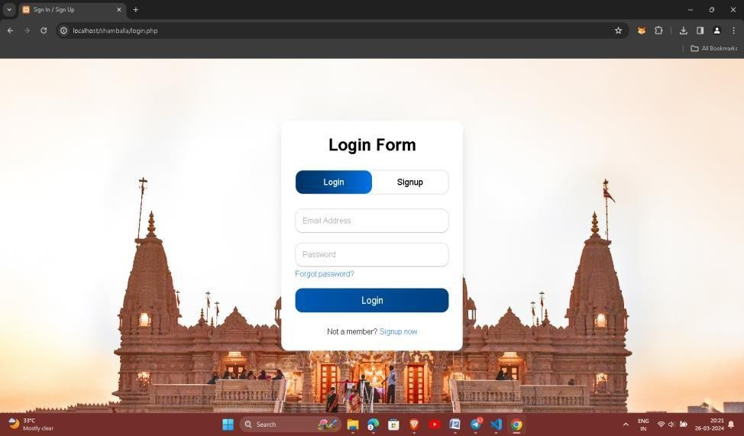

  - It is login page.
  - Enter your username and password.
  - Then click to SignIn.

Signup page:-
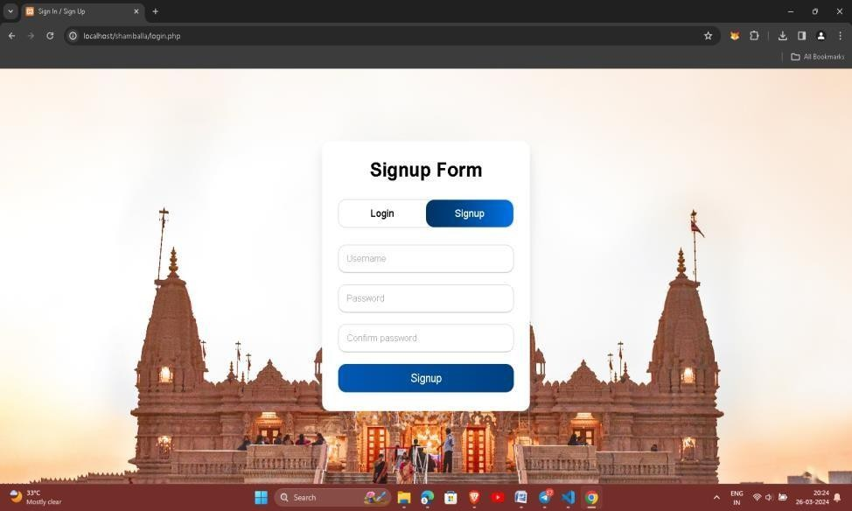

  - It is signup page.
  - Here user can create account.
  - Simple enter a username, password and confirm password.
  - Click to signup.

product order page

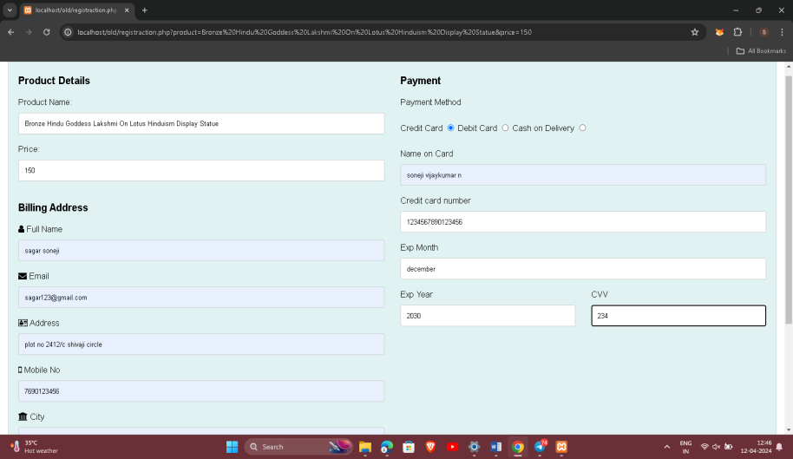

  - here product order to fill up this all details.
  - Also choose payment method.

Events:-
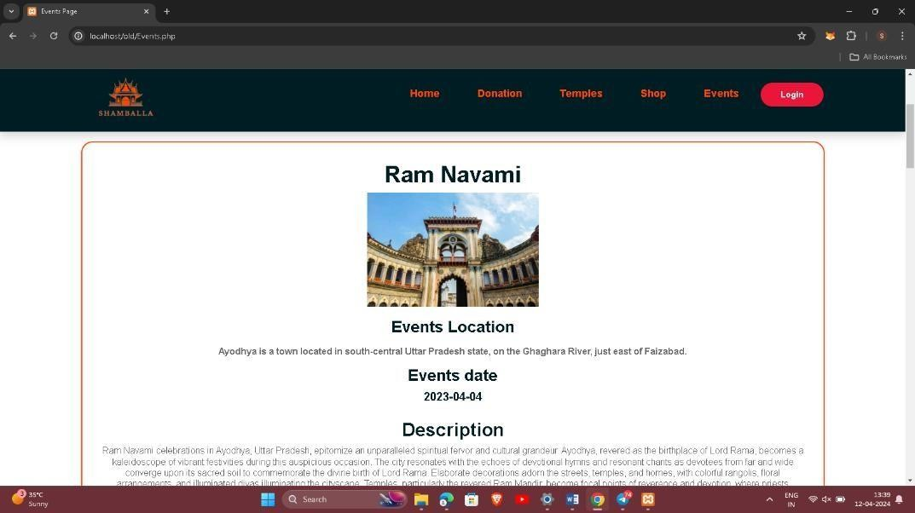

- This is temple event page .
- It is show the which temple has celebrate events and also event date, event name , event description and event location.

- Admin

1 Donation page

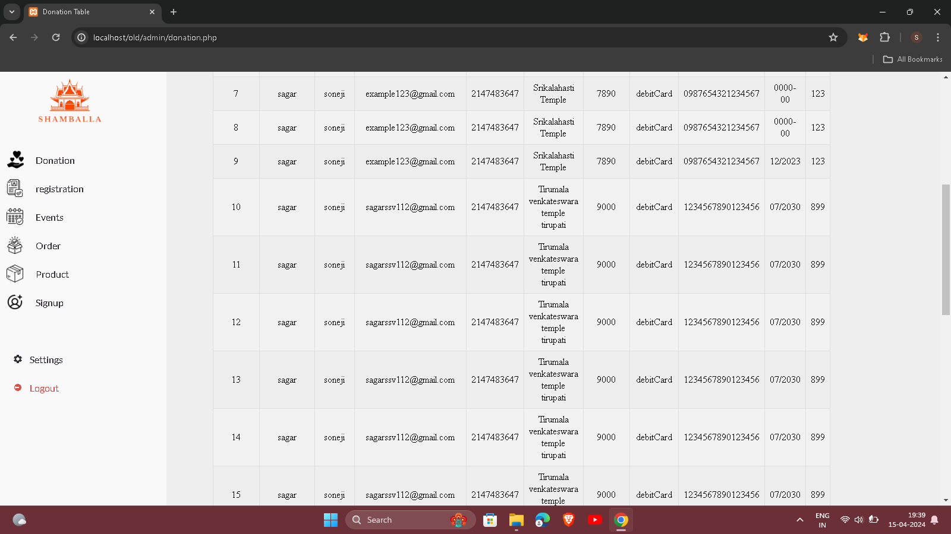

- This is admin side donation page
- Admin manage donation section.

2 registration :

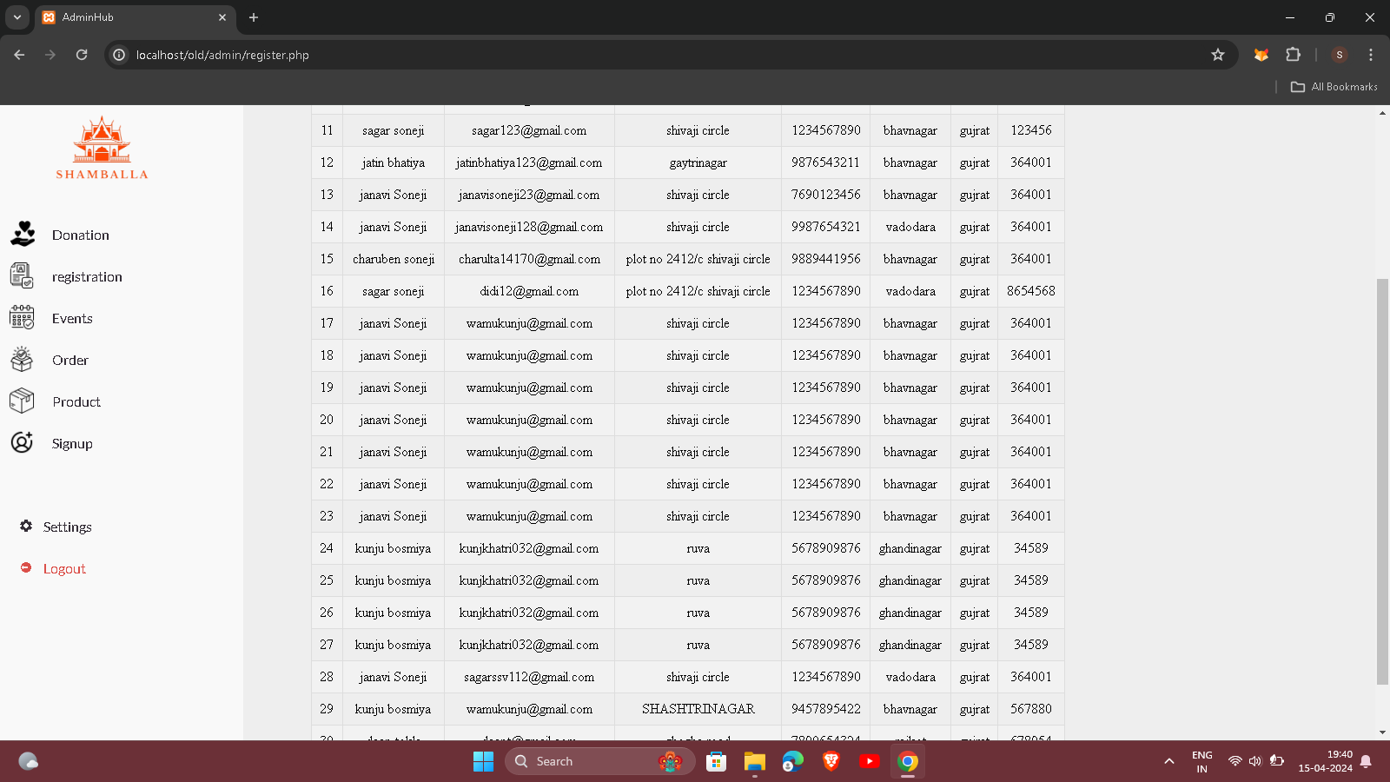

- This is admin side Registration section.
- Admin manage user registration page.

- Event

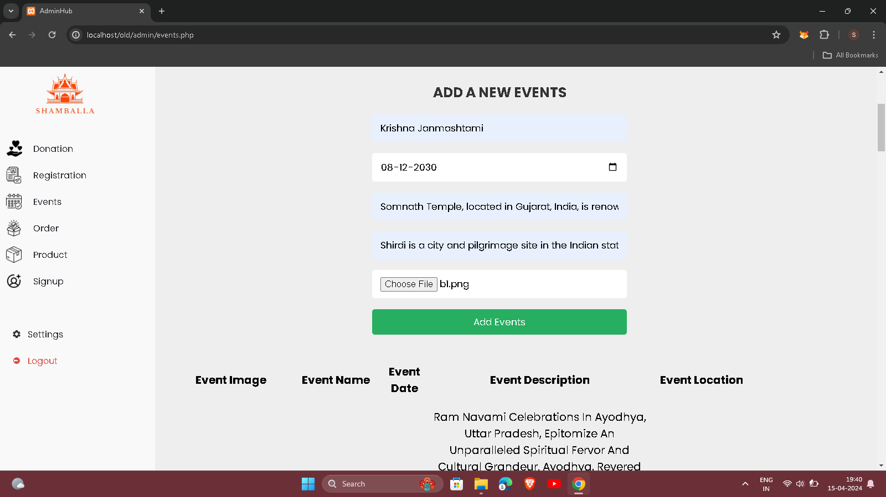

- Admin can add, edit and delete events from admin panel.

4 order

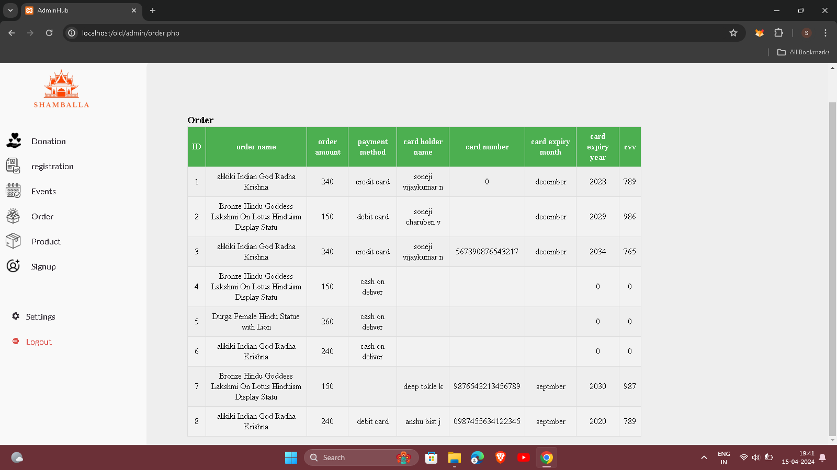

- Admin manage user order item .

- add product

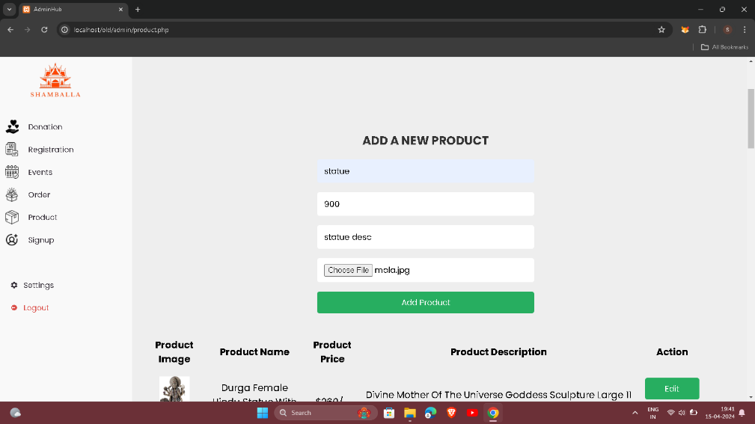

- here admin add product , remove product and edit product.

- signup

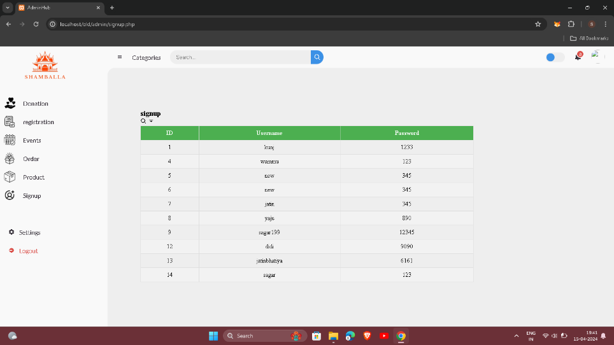
- this is user signup page detail .
- Page is manage by admin.

7.Testing and implementation

Testing and Implementation

Introduction of Testing

    - Software testing can be stated as the process of verifying and validating that software or application is bug-free, meets the technical requirements as guided by its design and development, and meets the user requirements effectively and efficiently with handling all the exceptional and boundary cases.

    - The process of software testing aims not only at finding faults in the existing software but also at finding measures to improve the software in terms of efficiency, accuracy, and usability. It mainly aims at measuring the specification, functionality, and performance of a software program or application.

Testing Objective

  - Testing is the process of executing a program with the intend of finding an error. A good test case is one that has high profitability of finding an as yet discovered error. A successful test is one that uncovers a yet undiscovered error.

Type of Testing:

- Code Testing
- Unit testing
- Integration testing
- Validation testing
- System testing
- Output testing
- User acceptance testing

Code Testing:
  - This was done side by side with coding thus examines the logic of the program. Every path of theprogram was tested.

Unit Testing:

  - To locate errors focus is given on the modules, independent of the other modules. This is known as unittesting. This enables us to detect errors and correct it without affecting any other modules. Thus, all the modules are individually tested from bottom up starting with the smallest level modules and proceeding one at a time.

Integration Testing:

  - Once the unit testing are through then the unit is integrated with the package and tested for its correctness and behaviors. A comprehensive integrated testing includes integrated test plans in the design phase of system.

Validation Testing:
  - At the conclusion of the integrated testing, software is completely assembled as a package. Interfacing errors have been uncovered and correlated. Then as find series of software test validation tests are carried out.

System Testing:

  - System testing is a series of different tests that verify all system elements have been properly integrated and performed allocated functions. Recovering testing was conducted by forcing the system to fail in all possibleways and verify that recovering is properly performed. Security test was conducted to verify that protection mechanism built into the system protects it from improper penetration.

Output Testing:

  - After performing the validation testing the next step is output testing of the proposed system since no systemcould be useful if it does not produce the output is the required format. Comparing the output with the format required by the user is output testing.

User Acceptance Testing:

  - User acceptance of a system is the key factor for the success of any system. The system under consideration was tested for user acceptance by constantly keeping the touch with the users of the organizationnecessary changes were made.

Different techniques of Software Testing

- Black Box Testing:

  - The technique of testing in which the tester doesn’t have access to the source code of the software and is conducted at the software interface without concern with the internal logical structure of the software is known as black-box testing.

White-Box Testing:

  - The technique of testing in which the tester is aware of the internal workings of the product has access to its source code and is conducted by making sure that all internal operations are performed according to the specifications is known as white box testing.

Test cases

- What is a Test case?

  - A test case is a document, which has a set of test data, preconditions, expected results, and post conditions, developed for a particular test scenario in order to verify compliance against a specific requirement.

  - Test Case acts as the starting point for the test execution, and after applying a set of input values; the application has a definitive outcome andleaves the system at some endpoint or also known as execution postcondition.

Typical Test Case Parameters:

  - Test Case ID
  - Test Scenario
  - Test Case Description
  - Test Steps
  - Prerequisite
  - Test Data
  - Expected Result
  - Test Parameters
  - Actual Result
  - Environment Information
  - Comments

Test Case Number | 1
Name | Valid Backend Admin Login
Description | This test case will check and allow administrator to log-in to system administrator / the backend of Second opinion system.
Input Data | - Enter valid username  - Enter valid password
Expected Output | - System need to check if username and password is valid into admin My SQL database.
Actual Result | System allowed login.

Test Case Number | 2
Name | Valid Signup User
Description | This test case will allow user to “request” to access Shamballa to administrator by fill-up Sign up.
Input Data | - Enter valid username  - Enter valid password  - Enter confirm password
Expected Output | - All fields are compulsory / require  - Username should be valid  - Enter valid password  - Enter confirm/renter password
Actual Result | System allow to store user and access system

Test Case Number | 3
Name | Valid Login User
Description | In this case only existing User can logged in.
Input Data | - Enter your username  - Enter your password
Expected Output | - Username and password should be compulsory / require.  - Without username and password can Entered a website.
Actual Result | System allow login.

Test Case Number | 4
Name | User Temple Donation.
Description | In this case only existing User can logged in.
Input Data | - Enter first name  - Enter last name  - Enter Mobile number  - Select Temple  - Email  - Donation amount  - Donation method
Expected Output | - All are compulsory /require.  - Choose donation method.  - Case 1:-Donation successfully redirect to recipt page .  - Case 2:-Donation detail require for donation
Actual Result | As expected.

Test Case Number | 5
Name | Buy a Product
Description | In this case User can Buy a Temples Related Product.  To fill up details.
Input Data | - Enter your full name  - Enter Mobile number  - Enter Email Address  - Enter Pincode  - Enter address  - Enter state  - Enter city  - Choose payment method
Expected Output | - All are compulsory /require.  - Enter your full name  - Enter your mobile number.  - Enter valid email address.  - Enter Your Pincode  - Enter address  - Enter state  - Enter city  - Choose payment method
Actual Output | As expected.

Test Case Number | 6
Name | Admin add product
Description | In this case Admin can Add a Temples Related Product with admin panel.
Input Data | - Enter Temple Product image.  - Enter product name.  - Enter product price  - Enter product description
Expected Output | - Admin can add product image , product name, product description and product price.
Actual Output | As expected.

Implementation

- Implementation is the stage where the theoretical design is returned into a working system.

- The most crucial stage is achieving a new successful system and in giving confidence on the new system for the users that it will work efficiently and effectively.

- The system can be implemented only after thorough testing is done and if it is found to work according to the specification.

- It involves careful planning, investigation of the current system and its constraints on implementation, design of methods to achieve the changeover and an evaluation of change over methods a part from planning.

- Two major tasks of preparing the implementation are education and training of the users and testing of the system.

- The more complex the system being implemented, the more involve will be the systems analysis and design effort required just for implementation.

- The implementation phase comprises of several activities. The required hardware and software acquisition is carried out.

- The system may require some software to be developed. For this, programs are written and tested. The user then changes over to his new fully tested system and the old system is discontinued.

8.Future Enhancement

Future Enhancement

  - Integrate virtual reality (VR) or 360-degree video tours to allow users to virtually explore the temple premises and experience its sacred spaces.

  - Implement live streaming capabilities for temple events, rituals, and ceremonies, providing a real-time connection for remote devotees.

  - Provide online courses, webinars, or downloadable resources that educate users about Hinduism, the temple's customs, and spiritual practices. Create a dedicated mobile app for the temple to enhance accessibility and provide on-the-go access to information, donations, and events.

    - Include information about the temple's location, contact details, visiting hours, and any special instructions for visitors.

    - Consider integrating a dynamic feature that automatically updates the timing based on the current time zone.

    - Include high-quality product images, detailed descriptions, and pricing information.

    - Optimize your website for mobile devices to ensure a seamless browsing experience for users accessing it from smartphones or tablets.

9.Conclusion

Conclusion

- The project was started as our learning experience which really helped us as to how deal with real world solution. This was new but wonderful experience of professional environment and many of the tools used, but we thought ―They know enough who know how to learn.

- While doing project, we learned many things and experienced the field of information technology. Doing small projects is different things, but we gained the actual knowledge of system analysis, design, coding and testing. The development of Shamballa and information system also had to be user friendly.

- We also gained the experience of solving the error. Intelligence is not to make any mistakes, but quickly to see how to solve them quickly .The system will replace the manual system, so it will be more efficient. Reliable and quick. We developed the system to satisfy as much requirements that are specified by the organization.

- Our website dedicated to Shamballa Temple aims to provide a welcoming online space for visitors seeking spiritual inspiration and community connection. Through user-friendly features and accessible information, we strive to offer:

- Insightful content about the temple's history, significance, and mission.

- Convenient schedules for aarti, darshan, and other religious rituals.

- Captivating images showcasing the temple's beauty and sacred spaces.

- Opportunities for visitors to contribute through donations and shop for spiritual items.

- Engaging events and activities to enrich the spiritual journey of our visitors.

10.Bibliography

Book Reference

    - PHP: The Complete Reference

Website Reference

    - https://www.w3schools.com/

    - https://www.youtube.com/@thesheryianscodingscho ol

